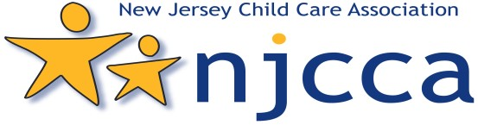 EXHIBITORS
Saturday October 1, 2022 at 1 Phalanx Road, Colts Neck, NJ 07722

NJCCA 2022 Leadership Symposium Vendor Application

Form

Saturday November 3, 2018

N
E

E
E

Must reserve by September 15, 2022.
NJCCA Business Member Rate $155.00 NJCCA Non-Member Rate $215.00
ALL INFORMATION MUST BE COMPLETED TO RESERVE YOUR EXHIBIT SPACE:

Company/Organization Name (for Conference Program):_____________________________________________________________

Contact Person/ Title:___________________________________________________________________________________________

Mailing Address:________________________________________________________________________________________________

City:_____________________________________________________State__________________________Zip_____________________

Tel.:____________________________Fax:___________________________E-mail:___________________________________________

Website: _______________________________Names for Name Badge(s)__________________________________________________

EXHIBITOR AGREEMENT:
I understand that submission of the Application and Contract for Table Space constitutes agreement to abide by NJCCA’s exhibit policies and information. Payment in full is due at time of application. Funds are to be made payable to NJCCA. There will be a $35 processing charge for returned checks. After September 15th only credit cards or money orders will be accepted. Cancellations prior to September 1, 2022 will incur a $35 administrative fee. Telephone cancellations not accepted; please notify us in writing before September 1, 2022. NO REFUNDS WILL BE MADE AFTER September 15th . NOTE: Exhibitors cannot break down their exhibit area until directed by NJCCA.

Signature of person making reservation:_____________________________________________________________

Total Amount Enclosed: $______________________ Please make checks payable to: NJCCA

Credit Card: (Circle One) MasterCard Visa American Express Discover

Cardholder Name: ___________________________________________________________________________ C V V Code (3 or 4 Digits)_____________________

Card Billing
Address:___________________________________________________________________City/State/ZIP_______________________________________________________

Account #____________________________________________________________________________________ExpirationDate: _____________/_____________

Cardholder Signature: _______________________________________________________________________
To ensure maximum exposure, please ensure your exhibit booth is occupied at all times. NJCCA encourages exhibitors to provide promotional items to attendees. Please scan and email form with payment to admin@njcca.org or fax to
201-643-3003. Payments can be made by check and mailed to: NJCCA, 223 14th Street, Palisades Park, NJ 07650.

